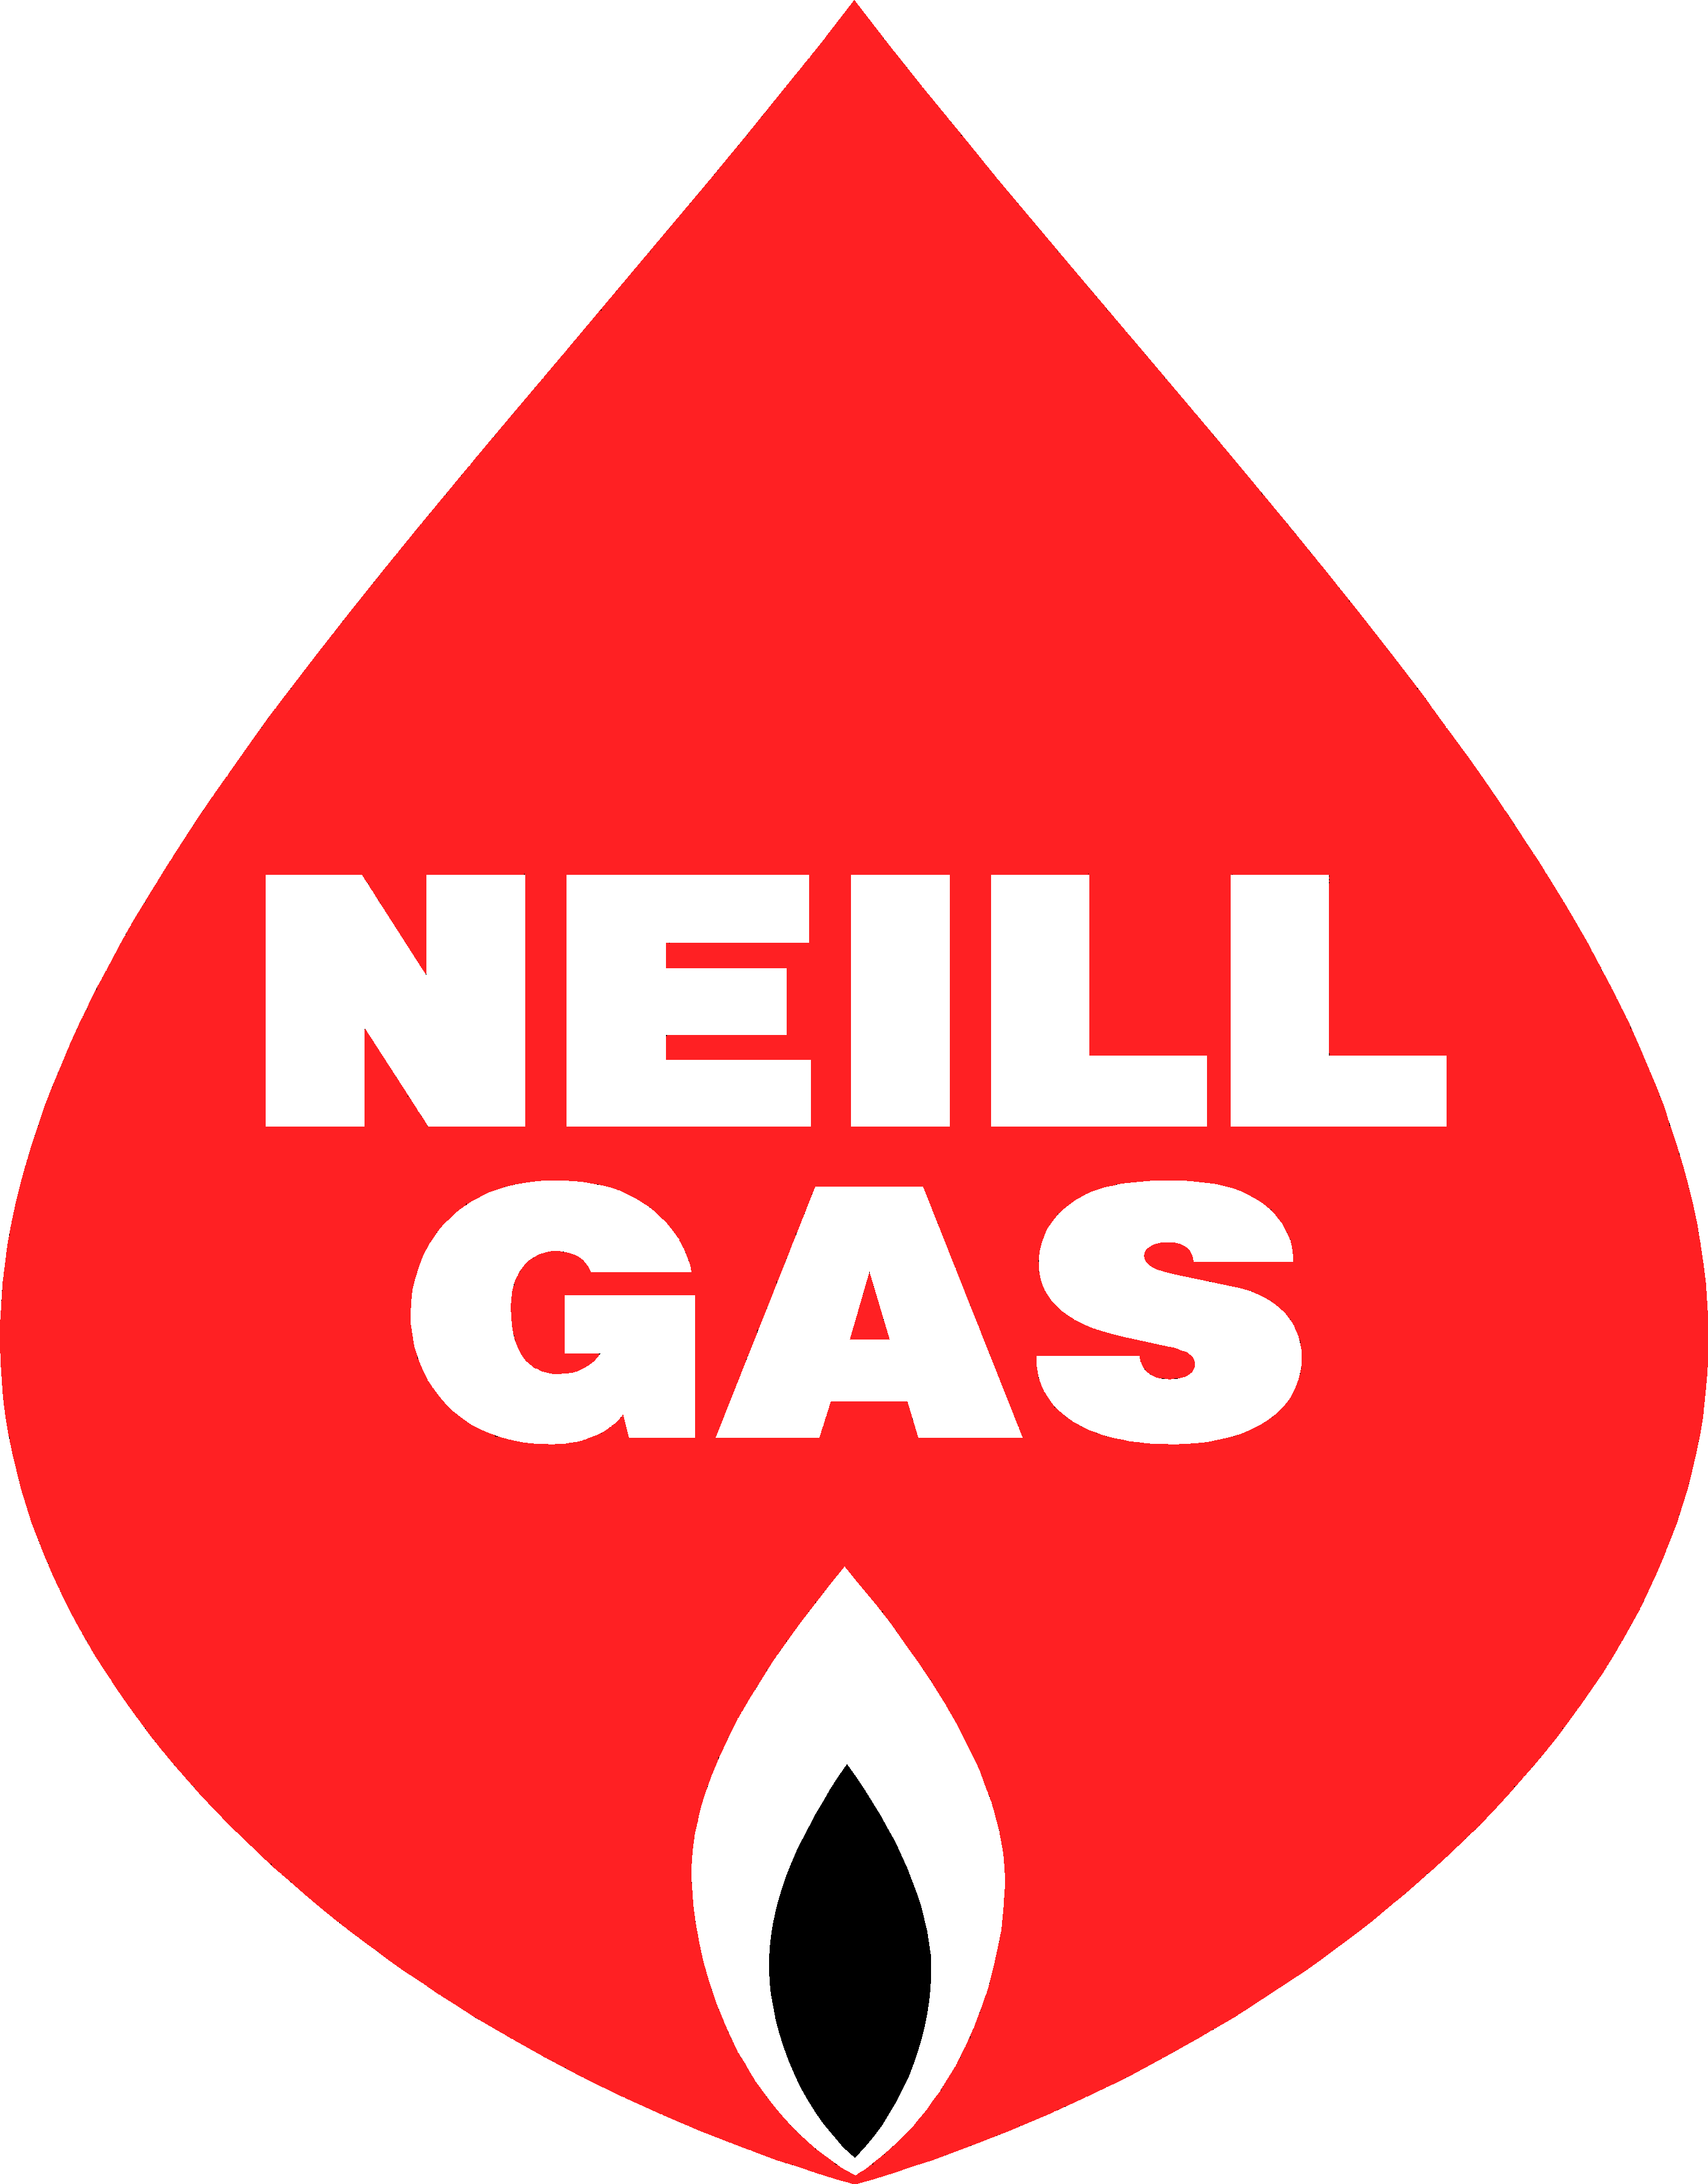
Main Office
P.O. Box 551
Vicksburg, MS 39181
Phone: (601)-636-0924

Neill Gas, Inc. offers Budget Billing!

Neill Gas Inc.’s Budget Billing allows customers to pay the same amount each month for propane based on the previous twenty-four months’ average total usage. This creates manageable payments each month and provides relief during high usage months. To qualify for this program, you must have a history of at least twelve months of propane service at the same location. Your account cannot have a past due balance and must have a zero balance. Credit history may be considered.

At the time of enrollment, your budget payment will be calculated, and you will receive notification of your monthly payment. Once enrolled, you will be auto renewed each July for the following 12 months Budget Billing program. The standard Budget Billing program is July 1st to June 30th. We do offer intermittent enrollment.

At the beginning of each month, you will receive a statement with your budget amount due. You are required to settle the account monthly and pay any amount that is owed in full at the end of the Budget Billing program in June. We do not allow carryover owed balances in the next budget year. If your account has a credit balance, the credit will be applied to the next budget year. We accept various forms of payment, including automatic credit card payment and monthly bank draft.

This program applies to propane use only. All yearly tank rental invoices and any other service invoices must be paid in full at the time of invoice based on your credit terms.

Please contact us for more information.

I understand the program as described above and would like to participate in Budget billing:

NAME: _ ________________________________

ACCOUNT NUMBER: _ ___________________________

PHONE NUMBER: _________ _____________________

EMAIL: _______________ ___________________________

SIGNATURE: _________________ ______________________

